

Name: ______________________ Term # ____
Programming Assignment 1
(100 points)

The Programming Assignment is to be turned in the first ten minutes of the due date class as:

Hardcopy (with your terminal #!)
Source Code and screenshots that shows that your Visual Studio 2008 “Programming Assignment 1” PROJECT compiles and runs!

Electronic: Submit the Visual Studio2008 “Programming Assignment 1” zipped PROJECT to BB so you can run it in 200 PGH!

HOUSE - Summer 2010 Modeling Instructions

1. The glutCreateWindow OpenGL call will take as parameter “YourLastName House”.
2. The file “House Summer 2010.pdf” contains the specifications for the house that you will start modeling in this first programming assignment.

3. Start with the MYcube.c that you have created in Homework 2 and call the file LowerHouse.c.
(No need to assign colors to each face of the cube since we will be able to differentiate between the front, the back, and the side of the house).

4. The “to scale” parts of the house required for this programming assignment are:

- “lower half” of the house (LowerHouse.c cube)

Front view Back View Side View
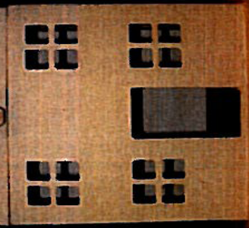,  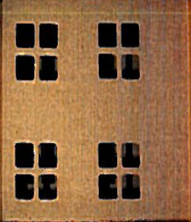

- the “door” (Door.c)

Front view
,

- the “window unit” (WindowUnit.c)

Front view
,

5. Each face of the “LowerHouse” cube will be created by calling a face. By definition, we signify a front of the face by specifying the order of the vertices counter clockwise and the back of the face by specifying the order of the vertices clockwise.
Thus, Front face is specified as 0,3,2,1, Back face is specified as 4,5,6,7, Right Side face is specified as 2,3,7,6 etc.
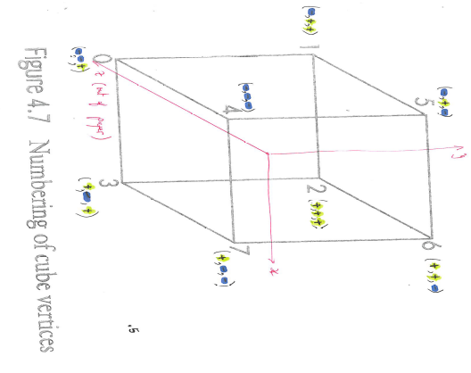

6. In the “void myReshape(int w, int h)” function, you need to adjust the viewing box to allow “glOrtho” to contain the parts of your house.

Get a screenshot of the “YourLastName House” window.

7. Adjust the camera so you can get the isometric image of LowerHouse (gluLookAt added to display function). This means that camera needs to be placed on the line from (0,0,0) to (1,1,1), aiming at the LowerHouse origin (0,0,0) and the up vector is on the y axis (0,1,0) (see Homework 2, part 8, page 30).

Get a screenshot of the “YourLastName House” window.

